GRADE 10 - CO-ORDINATE GEOMETRY
What is a Coordinate Plane or Cartesian Plane?
The coordinate plane or Cartesian plane is a basic concept for coordinate geometry. It describes a two-dimensional plane in terms of two perpendicular axes: x and y. The x-axis indicates the horizontal direction while the y-axis indicates the vertical direction of the plane. In the coordinate plane, points are indicated by their positions along the x and y-axes

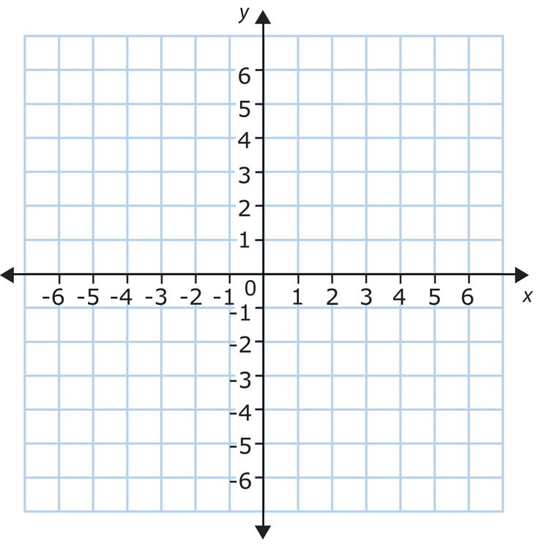Coordinate Geometry Formulas
The following table gives some coordinate geometry formulas.
 | FORMULA
- Gradient/Slope | $$\frac{y_{2}-y_{1}}{x_{2}-x_{1}}$$
- Midpoint | $$\left(\frac{x_{1}+x_{2}}{2};\frac{y_{1}+y_{2}}{2}\right)$$
- Distance | $$\sqrt{{{(x}_{2}-x_{1})}^{2}+{(y_{2}-y_{1})}^{2}}$$
How to plot points in the coordinate plane and how to determine the coordinates of points on the coordinate plane?
To graph or plot points, we use two perpendicular lines called axes. The point at which the axes cross is called the origin. Arrows in the axes indicate the positive directions.
Consider the ordered pair (4, 3). The numbers in an ordered pair are called the coordinates. The first coordinate or x-coordinate in this case is 4 and the second coordinate or y-coordinate is 3.
To plot the point (4, 3) we start at the origin, move horizontally to the right 4 units, move up vertically 3 units, and then make a point.
For example: In the coordinate plane below, point L is represented by the coordinates (–3, 1.5) because it is positioned on –3 along the x-axis and on 1.5 along the y-axis. Similarly, you can figure out the positions for the points M = (2, 1.5) and N = (–2, –3).
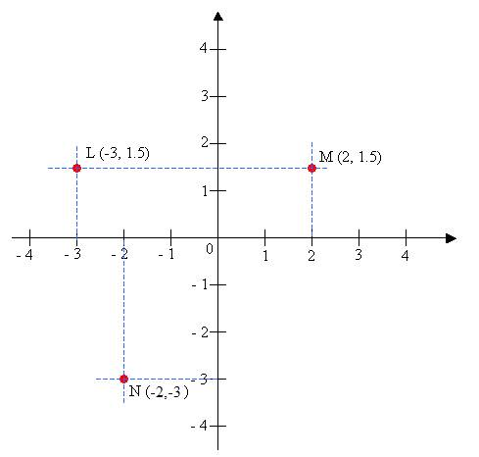

Exercise 1
Use the Cartesian plane above to plot the following points: A(-3,2), B(-1,4), C(-2,-4), D(0,-2), E(3,0)

